SWOT Analysis:
Strengths:
- User-friendly interface for voters.
- Three different user roles: voters, admins, and polling officers.
- Voters can only vote once, preventing multiple voting.
- Password-protected accounts for all users, ensuring security.
- Candidates can be added, removed, and declared a winner by polling officers.
Weaknesses:
- Only three test accounts are hardcoded, requiring manual addition of more users.
- Limited security measures for the database, such as encryption of passwords.
Opportunities:
- Implement additional user roles, such as candidates or election monitors.
- Implement two-factor authentication for user login.
- Improve database security measures, such as password encryption and limiting access.
- Allow for multiple elections to be conducted and recorded within the system.
- Enable election results to be exported for external auditing or reporting purposes.
Threats:
- Potential for hacking or cyber attacks on the system.
- Legal or ethical issues if the system is compromised or tampered with.
- Competition from other polling systems or voting methods.
- Potential for user error or technical issues during voting, leading to inaccurate results or system failures.

SDLC & Project Planning:
The software development life cycle (SDLC) for this polling system would include the following stages:
- Planning: Define the system requirements and objectives, determine the project scope, and identify potential risks and constraints.
- Analysis: Gather and analyze user requirements, create use cases and requirements documents, and develop a system design.
- Design: Develop a detailed system design, including database schema, user interface design, and software architecture.
- Implementation: Code the system according to the design specifications, perform unit testing and integration testing, and refine the system as needed.
- Testing: Perform system testing, user acceptance testing, and quality assurance testing to ensure the system is functioning correctly and meeting user requirements.
- Deployment: Deploy the system in a production environment, train users, and perform system maintenance and upgrades as needed.
- Support: Provide ongoing technical support, bug fixes, and system updates to ensure the system is meeting user needs and functioning optimally.
Project planning for this system would include defining project milestones, creating a Gantt chart or other project management tool, identifying project resources and stakeholders, and setting a project timeline and budget. Communication and collaboration between developers, project managers, and stakeholders will be crucial to the success of the project.

Use Case Diagram:
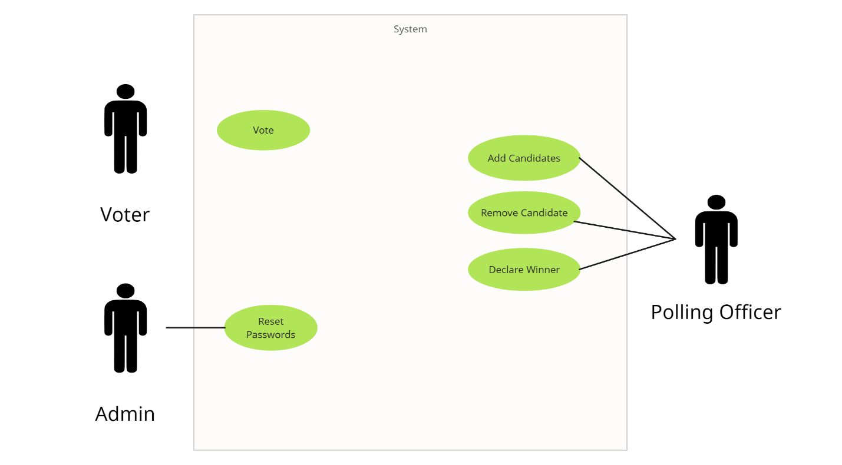

Class Diagram:
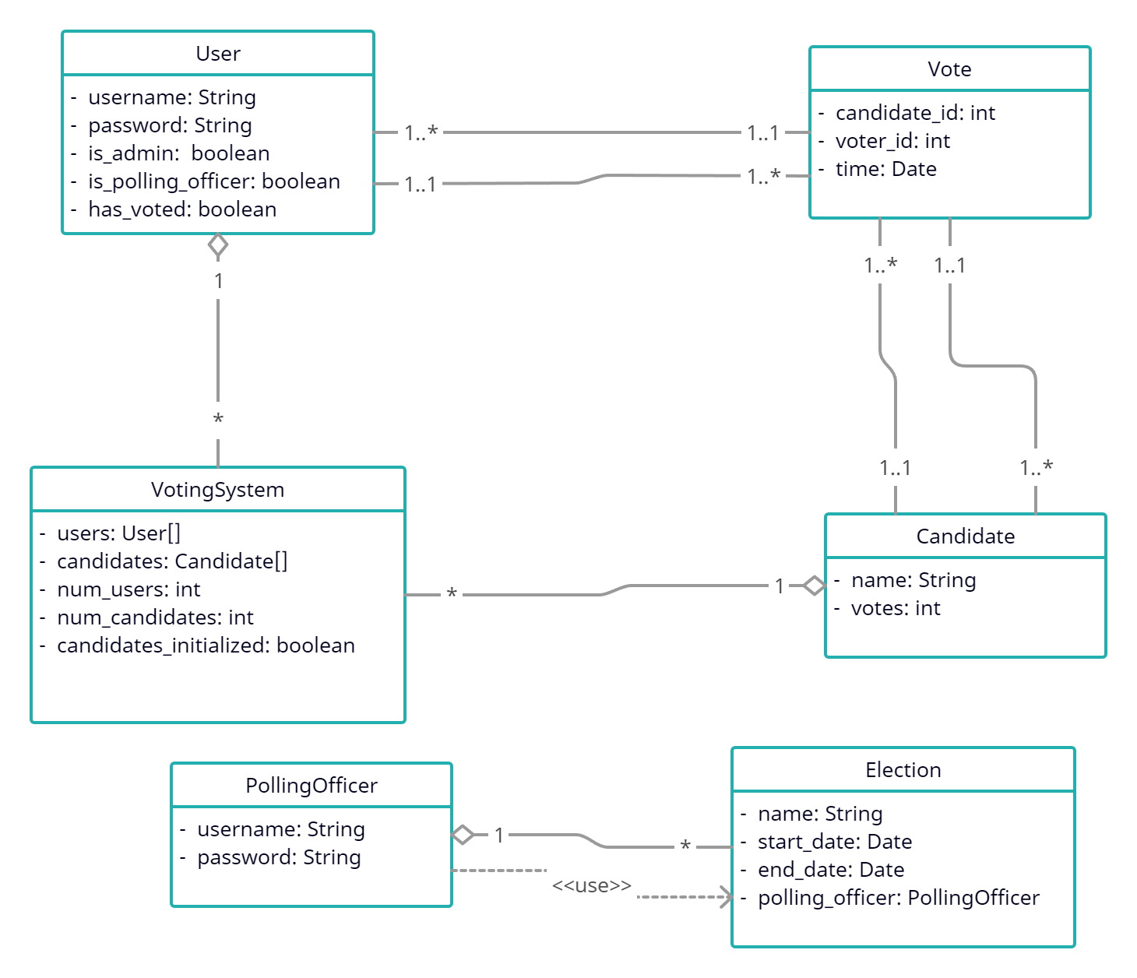

Test Case Scenarios:
Test case scenarios for the polling system might include the following:
- Login:
- Enter valid username and password: Successful login
- Enter invalid username or password: Login fails
- Attempt to login as polling officer or admin without valid credentials: Login fails

- Vote:
- Select valid candidate: Vote is recorded, user is prevented from voting again
- Select invalid candidate: Vote is not recorded, user is prompted to select a valid candidate

- Reset User Password (Admin):
- Enter valid username and new password: Password is reset
- Enter invalid username or password: Password reset fails

- Add Candidate (Polling Officer):
- Enter valid candidate name: Candidate is added to the list
- Enter invalid candidate name: Candidate is not added to the list
- Remove Candidate (Polling Officer):
- Select valid candidate: Candidate is removed from the list
- Select invalid candidate: Candidate is not removed from the list
- Declare Winner (Polling Officer):
- Multiple candidates have same number of votes: Winner is declared based on tiebreaking rules
- No votes have been cast: No winner is declared
- Only one candidate: That candidate is declared the winner

